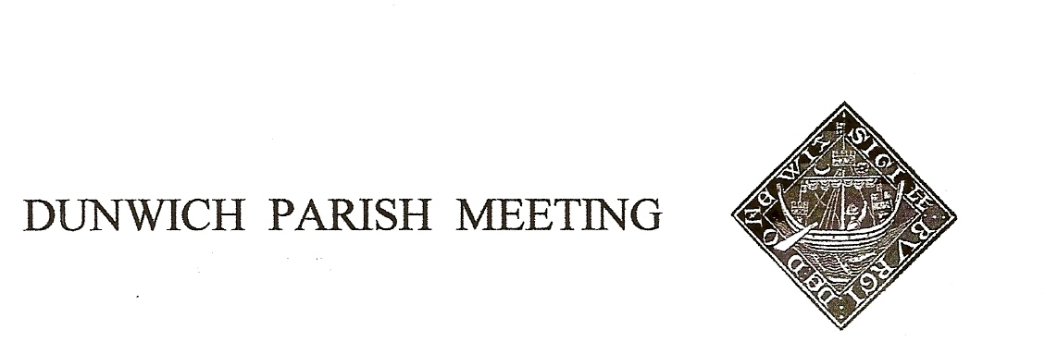Draft Minutes of Dunwich Parish Meeting held on 8th January 2021, held via Zoom under Coronavirus restrictions.

Meeting commenced at 7.30pm

- Welcome and apologies for absence:
Present: Dunwich Electors: R Smith (Chairman), G&A Abell, , D Boechler, C Brookhouse, J Cary, D&H Cook, J Hamilton, N&S Malkin, J Sharp, S&A Strickland, R Walter, J Zarins, M Whitby
Dunwich Non-Electors: C Blauth, T Roberts, L Beaumont,
Visitors: N. Mayo,
Apologies:, M Salusbury, G&M Williams, S Earp, B&M White

- Election of Parish Meeting Representative Trustees to Dunwich Town Trust
Three Trustees were retiring by rotation and standing for re-election. All were re-elected nem con.
Rod Smith, proposed by Judith Sharp, seconded by Nick Malkin
Crispin Clay, proposed by Christine Palmer, seconded by Angela Abell
Dennis Cox, proposed by Geoff Abell, seconded by Jane Zarins

- Minutes of the Parish Meeting held on 24th July 2020.
Acceptance of the Minutes of the 24th July 2020 Parish Meeting was proposed by Angela Abell, seconded by Chris Brookhouse, and they were duly signed by the Chairman.

- Matters arising from the minutes not otherwise on the agenda.
Chairman had been in contact with Paul Patterson (District Council) and Gary Watson (Environment Agency) regarding their giving the Meeting an update on the latest LIDAR data on Dunwich beach erosion rates. It had been agreed the best date for this would be the July meeting.
- Treasurer’s Report. Present balance £2,038. Geoff Abell took the Meeting through current year forecast figures and a budget for next year. Largest item in current year was purchase of the traffic control on Westleton Road, costing £3,836 and funded by £2,000 grants from DTT and District Councillor’s fund, plus the doubling of our precept to £2,000. No similar scale of expenditure was envisaged for next year, so the outline budget and a £1,000 precept was proposed by Mark Whitby, seconded by Jane Hamilton, and agreed with one objector.
The current year’s figures contained two elements of which the Meeting had not been previously advised. A repair was required on the notice board on the beach car park, cost £70.43, and a request for funding had been received from Leiston CAB – officers proposed £150 in line with previous years. Unanimously agreed.
Doug Boechler explained the annual risk assessment, which was accepted. Tim Roberts suggested an additional section to cover GDPR risks (data loss, subsequent fine).

- Amenity Report
- Traffic Calming. There was general agreement that the new sign on Westleton Road was very effective, and all the better for containing a polite message. Chairman was in touch with Highways for the installation of a second pole on the Blythburgh Road so the control could be moved from time to time to avoid user fatigue.
- Dog Management. Removal of the 2 dog poo bag dispensers was proposed on the grounds that responsible dog owners will have their own bags, the rest will not use them even if provided and our continued provision of them was not good value for money. Agreed.
Discussion continued on irresponsible owners throwing away filled bags rather than binning them. John Cary suggested another at the top of Monastery Hill near the corner of the monastery wall. Geoff Abell will contact Norse to check their appetite for emptying more (there are already 8 bins in the village). Signage to encourage their use was suggested, but opposed by some on clutter grounds. One box at the beach needs replacement – DTT have offered funding.
- Telephone Box. Ownership had now transferred to the Meeting but the box remains in situ courtesy of the landowner David and Heather Cook. BT are in process of upgrading the lighting for us and the inside will soon be pressure washed. Chairman invited proposals for use; following were proposed – community information, book swap, defibrillator housing (better located near the Ship), historic information (focusing on the estate village), interactive game à la Southwold Pier (insufficient power supply and very expensive to install). It was pointed out that the door is very heavy and needs to be eased before use. To be considered further at next meeting.
- St James Street pavement. Two areas of concern. The area already meshed was currently bare, grass cover not having taken. Another attempt at seeding will be made this spring. Just west of that the bare ground has become very worn and has sunk well below the paved area creating a dangerous lip – Chairman had observed a pedestrian tripping and falling here this week. The paved area is narrow and the adjacent hedge forces pedestrians onto the grass. Various options were discussed – fill and seed, turf, tarmac or consolidated gravel. Meeting generally preferred a natural option, Chairman will seek further advice.
- Sizewell C and ‘Energy Coast’ infrastructure
Chairman reported having joined a multi-council approach to EdF to convene a new session of the Sizewell Community Forum.

- Planning
There had been several applications since the last Meeting; the only one that had raised multiple objections from the village – at Little Greyfriars – remained undetermined by the planners.

- Any Other Business - None

- Date of Next Meeting: Friday 30th April 2021.
There being no further business the Meeting closed at 8.55pm.

