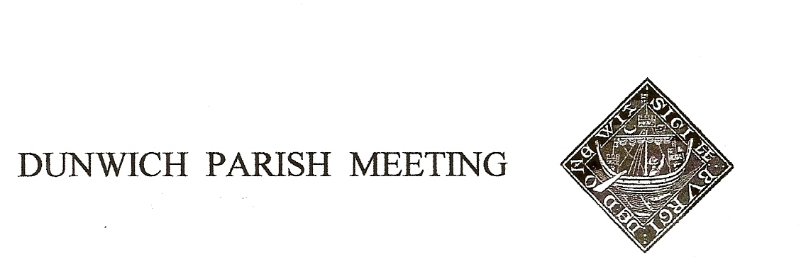
Draft Minutes of Dunwich Parish Meeting held on
23rd July 2021, in Dunwich Reading Room.
Meeting commenced at 7.30pm with a minute’s silent reflection following the death of Katharine Riches

1. Welcome and apologies for absence:
Present:: R Smith (Chairman), G Abell, L Beaumont, R Bessell, D Boechler, D Cook, D Copnall, S&J Earp, J Hamilton, S Hargreaves, M Holt, E Neilson, C&M Palmer, T Roberts, J Sharp, R Sutton, G Wielander, M Williams
Visitors: N. Mayo, R&A Curtis, P Patterson (East Suffolk DC), G Watson (Environment Agency)
Apologies:, A Abell, P Borel, C Brookhouse, J Cary, H Cook, J Godfrey, C Scott, M Sheppard, S Strickland, R Walter, C Weisser, M&J Whitby, B&M White, G Williams, J Zarins

2. Minutes of the Parish Meeting held on 30th April 2021. Acceptance of the Minutes of the 30th April 2021 Parish Meeting was proposed by Jane Hamilton, seconded by Maureen Williams, and agreed with no objections, and they were duly signed by the Chairman.

3. Matters arising from the Minutes not otherwise on the agenda. None

4. Treasurer’s Report. Present balance £2,321. Doug Boechler explained that because of the necessity of insuring the new traffic control, our premium was now £345pa rather than the £175 budgetted. Agreed.

5. Coastal Defence. Paul Patterson and Gary Watson presented the latest data on the profile changes of the beach shingle between Walberswick and the end of the cliff at National Trust Dunwich. Apart from some accretion at Walberswick and loss at NT there had been negligible change over the rest of the beach length, particularly in front of the village, during the 3 years since the previous report. Paul will be sending copies of his slides in due course, which will be shared with the village..

6. Jubilee 2022/ Jubilee Committee. In light of the Queen’s Platinum Jubilee next year and the ensuing national celebrations, the Chairman made a STRONG APPEAL for volunteers to step forward to rejuvenate the Jubilee Committee and lead Dunwich’s celebrations. The committee currently has no chairman or treasurer, both previous holders being no longer resident.
The Parish Meeting Chairman had received a letter from the county Lord Lieutenant inviting Dunwich to participate in the Festival of Suffolk in 2022, no details provided. It was agreed that any decision on our participation could wait until more details are available and we have a Jubilee Committee to coordinate it.

7. Amenity Report

Quiet Lanes Initiative: Sharon Earp outlined the scheme which aims to highlight the respect due by car drivers to other road users (and may incidentally calm the traffic). Leet Hill and Monastery Hill have been proposed

for inclusion and 3 signs would be required, preferably using existing posts. Highways had completed a traffic assessment and approved. Following the community Zoom consultation in June, we have been provisionally accepted for the 3rd wave in Suffolk. The cost was estimated to total £1,000 but several sources of grant may be available and the cost to the Parish Meeting budget should be modest. It was proposed by Tim Roberts, seconded by Donna Copnall that the Parish Meeting adopts the proposed QLS scheme for Dunwich, covering Monastery Hill and Leet Hill and makes an appropriate contribution to the costs of the scheme. Passed by 12 votes to 3.

Telephone Box: Cleaning has been completed, windows removed for paint stripping and partial replacement. Sanding and painting will follow shortly and Chairman will be asking for volunteers.

Dunwich Dynamo. Takes place on 24/25th July, but few participants anticipated.
S-bend at top of village. The land is currently in process of being sold; Chairman will approach the new owner to seek agreement to cut the hedge to improve sight lines. It was said that the job could be done very quickly and cheaply by an agricultural contractor. While all agreed, it was pointed out that we cannot simply cut it without the landowner’s agreement.
Post of Amenity Warden. Chairman made another STRONG APPEAL for a volunteer to take on this important role for the village, monitoring and reporting to the Meeting on developments, natural and created, that affect the wellbeing of all members of the community
8. New posts on High Street. Chairman explained that this was on the agenda at the request of a resident of Long Row and invited comments. A robust discussion ensued. It was strongly put by a number of people that whatever justification for the installation was believed, the essential fact was that that it had happened without any prior discussion or consultation with neighbours who now consider themselves adversely affected. The householder concerned expressed regret for any offence caused and distributed a long paper to those present at the meeting explaining their position. Chairman said he regarded the matter as being a dispute between neighbours, in which the Parish Meeting has no role and no powers of enforcement. He urged the parties to continue, in another venue, their own attempts to reach a compromise settlement.
9. Any Other Business. The arrangements for a Service of Thanksgiving for the life of Katharine Riches were read out.
- Date of Next Meeting: Friday 29th October.

There being no further business the Meeting closed at 9.15pm.

